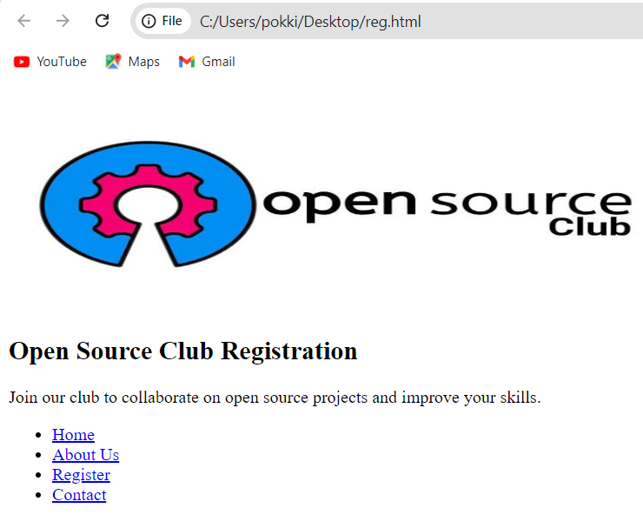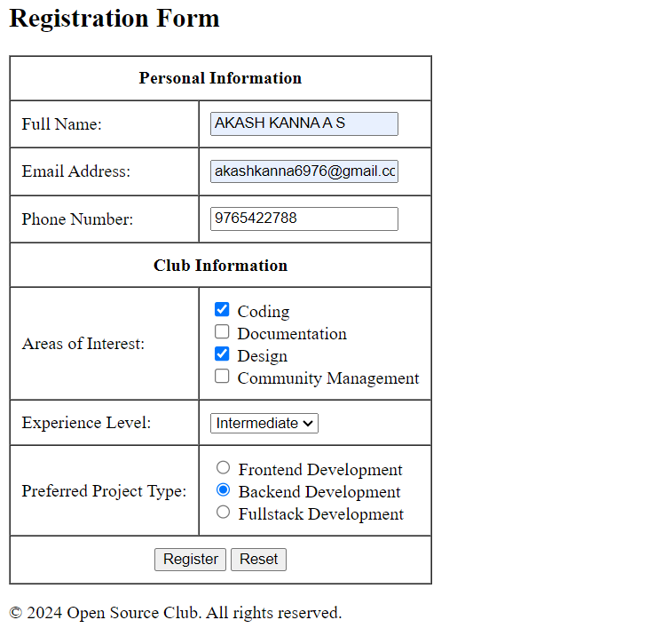

CODE:

<!DOCTYPE html>

<html lang="en">

<head>

<meta charset="UTF-8">

<meta name="viewport" content="width=device-width, initial-scale=1.0">

<title>Open Source Club Registration</title>

</head>

<body>

<img src="C:\Users\pokki\OneDrive\Documents\akk.jpg" alt="Open Source Club Banner" width="600" height="200">

<!-- Main Content -->

<main>

<!-- Article Section -->

<article>

<header>

<h1>Open Source Club Registration</h1>

<p>Join our club to collaborate on open source projects and improve your skills.</p>

</header>

<!-- Navigation -->

<nav>

<ul>

<li><a href="#home">Home</a></li>

<li><a href="#about">About Us</a></li>

<li><a href="#register">Register</a></li>

<li><a href="#contact">Contact</a></li>

</ul>

</nav>

<!-- Registration Form Section -->

<section id="register">

<h2>Registration Form</h2>

<!-- Image added here -->

<form action="#" method="POST">

<!-- Table for Form Layout -->

<table border="1" cellpadding="10" cellspacing="0">

<tr>

<th colspan="2" scope="col">Personal Information</th>

</tr>

<tr>

<td><label for="name">Full Name:</label></td>

<td><input type="text" id="name" name="name" required></td>

</tr>

<tr>

<td><label for="email">Email Address:</label></td>

<td><input type="email" id="email" name="email" required></td>

</tr>

<tr>

<td><label for="phone">Phone Number:</label></td>

<td><input type="tel" id="phone" name="phone"></td>

</tr>

<tr>

<th colspan="2" scope="col">Club Information</th>

</tr>

<tr>

<td><label for="interests">Areas of Interest:</label></td>

<td>

<input type="checkbox" id="coding" name="interests" value="coding">

<label for="coding">Coding</label><br>

<input type="checkbox" id="documentation" name="interests" value="documentation">

<label for="documentation">Documentation</label><br>

<input type="checkbox" id="design" name="interests" value="design">

<label for="design">Design</label><br>

<input type="checkbox" id="community" name="interests" value="community">

<label for="community">Community Management</label>

</td>

</tr>

<tr>

<td><label for="experience">Experience Level:</label></td>

<td>

<select id="experience" name="experience">

<option value="beginner">Beginner</option>

<option value="intermediate">Intermediate</option>

<option value="advanced">Advanced</option>

</select>

</td>

</tr>

<tr>

<td><label for="preference">Preferred Project Type:</label></td>

<td>

<input type="radio" id="frontend" name="preference" value="frontend">

<label for="frontend">Frontend Development</label><br>

<input type="radio" id="backend" name="preference" value="backend">

<label for="backend">Backend Development</label><br>

<input type="radio" id="fullstack" name="preference" value="fullstack">

<label for="fullstack">Fullstack Development</label>

</td>

</tr>

<tr>

<td colspan="2" style="text-align:center;">

<input type="submit" value="Register">

<input type="reset" value="Reset">

</td>

</tr>

</table>

</form>

</section>

</article>

</main>

<!-- Footer -->

<footer>

<p>&copy; 2024 Open Source Club. All rights reserved.</p>

</footer>

</body>

</html>